**PART-I (GENERAL INTELLIGENCE & REASONING)**

Q1. Consider the following information regarding the performance of a class of 1000 students in four different tests.

|  |  |  |  |  |
| --- | --- | --- | --- | --- |
| Tests | I | II | III | IV |
| Average Marks | 60 | 60 | 70 | 80 |
| Range of Marks | 30 to 90 | 45 to 75 | 20 to 100 | 0 to 100 |

If a student scores 74 Marks in each of the four tests, in which of the following tests is his performance the best comparatively?

(a) Test – I

(b) Test – II

(c) Test – III

(d) Test – IV

Q2. If ‘MEDICAL’ is written as ‘DEMILAC’ how is ‘SUBJECT’ written is the code?

(a) BUSJETC

(b) BUSTCTE

(c) BUSJTCE

(d) BUJSCTE

Q3. Observe the following diagram carefully and find out the particular portion which represents for those women who are employed but not married.

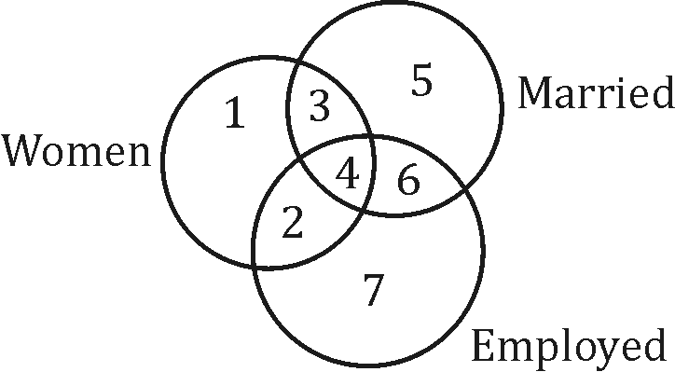

(a) 2

(b) 3

(c) 4

(d) 6

Directions: have been coded but no specific sigement to pic the coded word the best.

Q4. RUDDER:

(a) S V E E F S

(b) S V V K L T

(c) A C C C Q R

(d) B B M T Y X

Q5. These question follow some pattern, choose the correct different to fill the places for question marks.

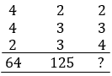

(a) 125

(b) 625

(c) 325

(d) 525

Q6. Three views of the same cube are shown below.

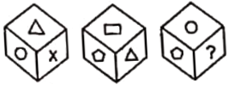

E figure on the face opposite the triangle is:

(a) Pentagon

(b) Circle

(c) Question mark

(d) Rectangle

Directions (7-8): Given below are three positions of the same dice having names of six instructions inscobed on six faces. The names of there instructions are ICA, ICWA, ICSI, ICF, AI, IIT, BHU

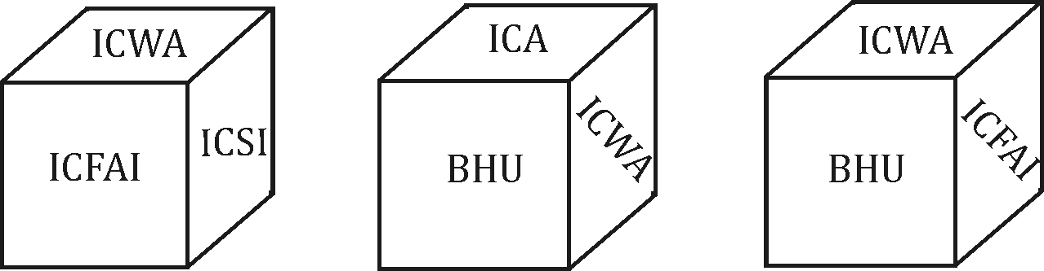

Q7. Which name occurs on the face opposite to that of ICA?

(a) ICSI

(b) ICFAI

(c) IIT

(d) None of these

Q8. Which name occurs on the face opposite to that of IIT?

(a) ICSI

(b) IFCAI

(c) BHU

(d) None of these

Q9. Pick the odd one out.

(a) Tegonometry

(b) Geometry

(c) Mathematics

(d) Algebra

Q10. Anuraag is 40 m South-West of Vikram Chiraag is 40 m South-East of Vikram, then Chiraag is in which direction of Anuraag?

(a) North-East

(b) South

(c) East

(d) South-East

Q11. If 16 ⊕ 27 = 48 and ⊕ 39 = 51 then what will be the value of 25 ⊕ 48 = ?

(a) 47

(b) 63

(c) 53

(d) 57

Q12. Pointing towards the photograph of a person, Alka said, “He is the only son of the father of my sister’s brother”. How is that person related to Alka?

(a) Uncle

(b) Mother

(c) Father

(d) Brother

**Directions:** Word has been coded but no specific code is indicated. Use your logic to pick the coded word which represents the given word the best.

Q13. AGGRAVATE:

(a) 1 4 4 5 1 6 1 7 8

(b) 1 4 4 4 5 2 2 7 8

(c) 1 9 2 2 2 7 1 5 6

(d) 1 7 2 5 5 5 2 1 1

**Directions:** Select the suitable alternative to satisfy the relationship in the following question.

Q14. Question figure

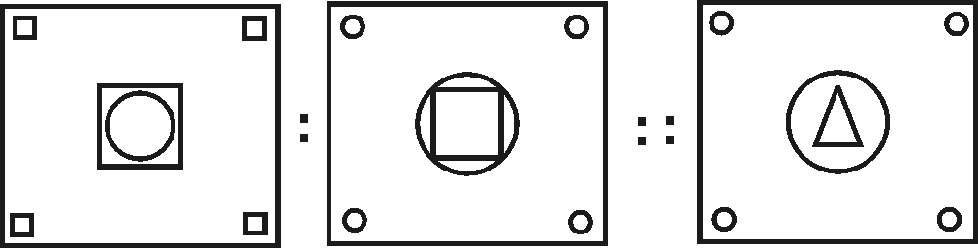

Answer Figure

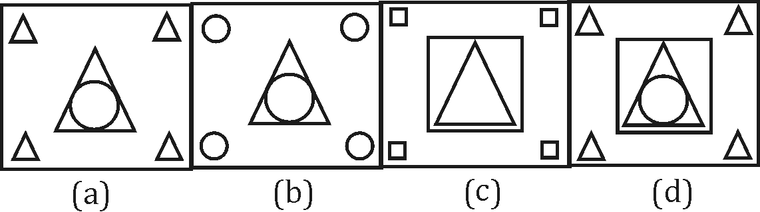

**Directions (15-17):** Read the following statement carefully and then answer the questions qiven under it

From a batch of six batsman- Sahwag, Gambhir, Dravid, Dhoni, Youvraj and Tendulkar and four ballers- Praveen, RP Singh, Kapildev, Ishant, a team of six players is to be selected for participating in international Cricket League some of the criteria are-

I. Gambhir and Dhoni have to be together

II. Dravidcan not go with R P singh

III. Tendulkar can not go with Sahwag or Dhoni

IV. Praveen and Kapildev have to be together

V. Praveen can not go with Ishant

VI. Sahwag and Youvraj have to be together

Unless otherwise mentioned, the above criteria are applicable to all the following questions.

Q15. If four of the members including Youvraj have to be batsman and one of the baller has to be Kapildev, the team consists of:

(a) Sahwag, Gambhir, Dhoni, Youvraj, Kapildev, Ishant

(b) Gambhir, Dhoni, Youvraj, Tendulkar, Praveen, Kapildev

(c) Sahwag, Dhoni, Youvraj, Tendulkar, Praveen Kapildev

(d) Sahwag, Gambhir, Dhoni, Youvraj, Praveen, Kapildev

Q16. If at least three members have to be ballers and Dravid agrees to team with R. P. Singh but R. P. Singh refuses to team with Sahwag, the team consists of:

(a) Gambhir, Dhoni, Youvraj, Praveen. R.P. Singh Ishant

(b) Gambhir, Dravid, Dhoni, Praveen, Kapildev, Ishant

(c) Praveen, Ishant, Kapildev, Sahwag, Dravid, Youvraj

(d) Praveen, R. P. Singh, Kapildev, Gambhir, Dravid, Dhoni

Q17. If three members including Dravid have to be batsman and Ishant agrees to team with Praveen while Youvraj refuses to do so, the other members of the team are:

(a) Gambhir, Dhoni, R.P. Singh

(b) Gambhir, Dhoni, Kapildev

(c) Youvraj, Tendulkar, Ishant

(d) Sahwag Youvraj, R.P. Singh

Q18. In the below figure, circle P represents hardworking people, circle Q represents intelligent people, circle R represents truthful people, and circle S represents honest people. Which region represents the people who are intelligent, honest and truthful but not hardworking:

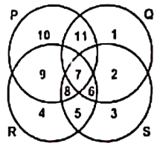

(a) 6

(b) 7

(c) 8

(d) 11

**Directions (19-22):** There are four diagrams shown below representing relationships between groups in the questions that follow, select the diagram that best represents the relationship for the question.

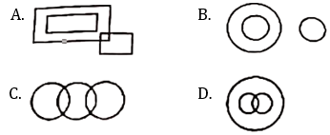

Q19. Humans, Indians, Football players:

(a) A

(b) B

(c) C

(d) D

Q20. Milk products, curd, oranges:

(a) A

(b) B

(c) C

(d) D

Q21. Umbrellas, red, clothes:

(a) A

(b) B

(c) C

(d) D

Q22. Organisation, managers, forests:

(a) A

(b) B

(c) C

(d) D

**Directions (23-26):** The Hindustan college is conducting a refresher course for students of seven different subjects- English, Physics, Mathematics, Zoology, Botany, Reasoning and General Awareness from 11 December to 18 December

1. Course should start with Physics

2. 12 December being Sunday, should be Holiday

3. Reasoning subject should be on the previous day of the General awareness subject

4. Course should end with English subject

5. Mathematics should be immediately after the Holiday

6. There should be a gap of one day between Botany and General Awareness.

7. Zoology should be immediately before English

Q23. Which subject will be conducted on Tuesday:

(a) Botany

(b) Reasoning

(c) Mathematics

(d) None of these

Q24. Which two subjects fall on same day:

(a) Mathematics, English

(b) Botany, Reasoning

(c) Physics, English

(d) None of these

Q25. On Wednesday which subject will be conducted:

(a) Reasoning

(b) Zoology

(c) General awareness

(d) Botany

Q26. How many subjects are there between Reasoning and English:

(a) 1

(b) 3

(c) 4

(d) 2

Direction: gives the marks scored by a subjects – English, Hindi, Mathematics and Social Science in an examination. Arranging that the total marks obtained for the examination are also, answer the question given below

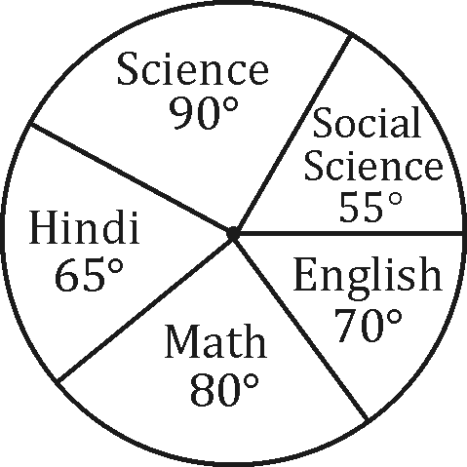

Q27. The difference of marks between Social Science and Mathematics as the same as between:

(a) English and Science

(b) Science and Hindi

(c) Hindi and English

(d) None of these

**Directions:** Complete the Series in the following figures.

Q28. Question figure

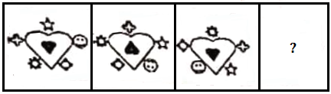

Answer figure

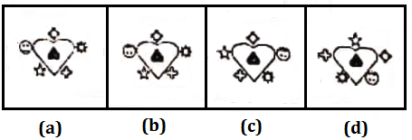

**Directions:** Complete the series in the following figures.

Q29. Question figure

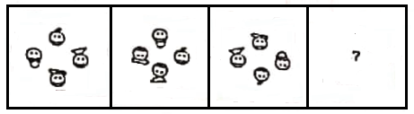

Answer figure

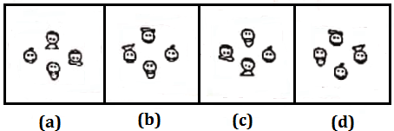

**Directions:** Compete the following series.

Q30. Question figure

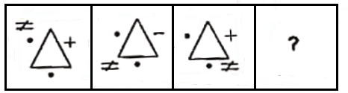

Answer figure

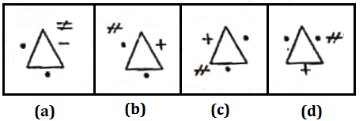

Q31. Five students participated in an examination and each scored different marks. Naina scored higher than Meena. Kamla scored lower than Praveen but higher than Naina. Anuj’s score was between Meena and Naina. Which of the following pairs represents the highest and the lowest scores respectively?

(a) Praveen, Naina

(b) Naina, Praveen

(c) Praveen, Anuj

(d) Praveen, Meena

**Directions (32-33):** There were six persons U, V, W, X, Y, Z playing a game of cards U’s father, mother and uncle were in the group. There were two ladies in the group. ‘V’ the mother of ‘U’ got more points than her husband. ‘X’ got more points than ‘Y’ but less than ‘Z’ Niece of ‘Y’ got lowest points Father of ‘U’ got more points than ‘Z’ but could not win the game.

Q32. Who won the game & who got the lowest points respectively:

(a) V & U

(b) U only

(c) W & Y

(d) X & V

Q33. Who is the husband of ‘V’ and what was his position in the game on the basis of points:

(a) Z, IInd

(b) Y, IIIrd

(c) X, IInd

(d) W, IInd

Q34. Pick the odd one out.

(a) Tiger

(b) Lion

(c) Leopard

(d) Wolf

Q35. A man stands on a tower and sees two hill peaks one in the north east and one in the north west. Both peaks are at the same distance from the tower. He climbs the top of the peak I the North East and looks at the other peak. Which direction does he look to do so.

(a) North-West

(b)

(c) South

(d)

Q36. If $\frac{{\left(Two\right)}^{2}}{{\left(Five\right)}^{2}}=\frac{9}{16},\frac{{\left(Six\right)}^{2}}{{\left(Seven\right)}^{2}}=\frac{9}{25},$ then $\frac{{\left(One\right)}^{2}}{{\left(Hundred\right)}^{2}}=1$

(a) $\frac{25}{9}$

(b) $\frac{16}{9}$

(c) $\frac{9}{49}$

(d) $\frac{9}{36}$

Q37. Three views of a cube following a particular motion are given below:

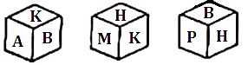

What is the letter opposite to A?

(a) M

(b) P

(c) B

(d) H

**Directions:** The following numerals are written in symbol from select the choice that represents the given number the best.

Q38. 55345511:

(a) $↑ ↑ → ↓ ↑ ↑ ∆ ∆$

(b) $↑ ↑ → ↓ ↓ ↑ ∆ ∇$

(c) $← ↓ → ↓ → ↑ ↓ ↑$

(d) $∆ ∇ → ↓ ↓∇ ∇ ↑$

Q39. 8 boys sat in a row. Raju is immediate right of Rakesh and immediate left of Shekhar, Shyam is sitting after 3 boys on the right of Shekhar. How many boys were there between Raju and Shyam:

(a) 3

(b) 4

(c) 5

(d) None of these

**Directions (40 & 41):** Select the suitable alternative to satisfy the relationship in the following questions.

Q40. XXIII : 46 :: VII:

(a) 14

(b) XIV

(c) X

(d) II

Q41. ACEG : BDFH :: PRTV:

(a) QRUW

(b) QSUW

(c) STUT

(d) QRST

**Directions (42 & 43):** Find the missing term in each of the following number series.

Q42. 4, 2, 6, 6, 3, 9, 8, 4, 12, 10, 5, ?

(a) 15

(b) 20

(c) 10

(d) 5

Q43. 3, 4, 12, 48, 4, 5, 20, 100, 5, 6, 30, 180, 6, 7, 42, ?

(a) 304

(b) 298

(c) 294

(d) None of these

**Directions (44 & 45):** In the following question, Select the choice of letters which completes the first word and begins the second. The letters in the bracket end the first word and begin the second Number of dots in bracket indicate number of letters required.

Q44. WAR (….) WELL:

(a) RING

(b) FAIR

(c) FARE

(d) PAIR

Q45. ASSU (. .) ASURE:

(a) RE

(b) EN

(c) ME

(d) AN

**Directions (46 & 47):** Select the suitable alternative to satisfy the relationship in the following question.

Q46. Buffalo : Leather :: Sheep:

(a) Wool

(b) Cotton

(c) Fur

(d) Silk

Q47. AZB : CXD :: EVF : ?

(a) HSR

(b) GTH

(c) GHT

(d) RIS

Q48. If 2 = 5, 4 = 18, 6 = 39 and 8 = 68 then 10 = ?

(a) 45

(b) 105

(c) 81

(d) 100

Q49. The most likely code for “Venezuela” is:

(a) 972754781

(b) 977254781

(c) 912154787

(d) 824265415

Q50. If KOLKATA is coded as LPMLBUB then MUMBAI can be coded as:

(a) NVODBJ

(b) PVQDEI

(c) LOLBAI

(d) NVNCBJ

**PART-II (GENERAL AWARENESS & PROFESSIONAL KNOWLEDGE)**

Q51. Holding of Panchayat elections is decided by:

(a) The District Magistrate

(b) Central Government

(c) State Government

(d) None of these

Q52. Which was the first committee to recommend Panchayati Raj system in India?

(a) PV Narsimha Rao committee

(b) Balwant Rai Mehta committee

(c) LM Singhvi committee

(d) Morarji Desai committee

Q53. Which of the following explains the phenomenon of twinkling of stars?

(a) Reflection

(b) Atmospheric Refraction

(c) Scattering of light

(d) Dispersion

Q54. ‘Permanent Settlement’ of 1793 dealt with …

(a) Arms control

(b) Citizen right of privacy

(c) Land revenue

(d) Public education

Q55. Kanishka was a king of the ………… dynasty.

(a) Kushana

(b) Chola

(c) Nanda

(d) Satavahana

Q56. In which of the following do the Tapti and Narmada rivers fall?

(a) Bay of Bengal

(b) Arabian Sea

(c) Indian Ocean

(d) Pacific Ocean

Q57. Disease causing microorganisms are known as-

(a) Antibodies

(b) Antigens

(c) Pathogens

(d) None of these

Q58. RTGS in banking sector stands for:

(a) Real Time Gross Settlement

(b) Real Transactions Going Settlement

(c) Ready Transfer Gross Settlement

(d) Remittance Transfer Gross settlement

Q59. Which of the following was not written by Kalidas?

(a) Kumar Sambhavam

(b) Laghujalakam

(c) Meghdootam

(d) Raghuvansham

Q60. Uber cup and Thomas cup are associated with:

(a) Chess

(b) Cricket

(c) Badminton

(d) Table Tennis

Q61. Pungency in chillies is due to:

(a) Capsaicin

(b) Solanin

(c) Isothiocyanates

(d) None of these

Q62. India’s first credit bureau through which commercial banks will share credit history of the customers:

(a) MCX

(b) CRISIL

(c) SEBI

(d) CIBIL

Q63. Which bone is the largest bone in human body

(a) Femur

(b) Humerus

(c) Tibia

(d) Radius

Q64. Match the states (List I) with their capitals (List II):

States (List I) Capitals (List II)

A. Chattishgarh 1. Kohima

B. Telangana 2. Agartala

C. Tripura 3. Gangtok

D. Nagaland 4. Raipur

E. Sikkim 5. Hyderabad

(a) A4, B3, C2, D1, E5

(b) A2, B5, C1, D4, E3

(c) A4, B5, C3, D1, E2

(d) A4, B5, C2, D1, E3

Q65. Match the following (item –I to item –II):

ITEM-I ITEM-II

A. Siachin Glacier 1. Sikkim

B. Rohtang Pass 2. Karakoram Range

C. Nathu la 3. Pakistan

D. Khyber Pass 4. Himachal Pradesh

(a) A4, B2, C3, D1

(b) A4, B2, C1, D3

(c) A3, B2, C4, D1

(d) A2, B4, C1, D3

Q66. Match List-I with List-II.

List-I List-II

1. Jawahar Lal Nehru Port A. Tamilnadu

2. Paradip Port B. Maharashtra

3. Kandla Port C. Odisha

4. Ennore Port D. Gujarat

(a) 1-D, 2-A, 3-B, 4-C

(b) 1-B, 2-C, 3-D, 4-A

(c) 1-D, 2-C, 3-B, 4-A

(d) 1-B, 2-A, 3-D, 4-C

Q67. Match the following:

Name of Unit used to Measure

A. Poise 1. Temperature

B. Farad 2. Quantity of Heat

C. kelvin 3. Viscosity

D. Calorie 4. Electrical capacitance

(a) A3, B4, C1, D2

(b) A4, B3, C2, D1

(c) A3, B4, C2, D1

(d) A1, B2, C3, D4

Q68. Who amongst the following elects the Vice President of India?

1. Members of Lok Sabha

2. Members of Rajya Sabha

3. Members Legislative Assemblies

4. Members of Legislative councils

Select the correct answer from the codes given below

(a) 1 and 2 only

(b) 1 and 3 only

(c) 1, 2 and 3 only

(d) 1, 2, 3 and 4 all

Q69. ‘Indian Standard Meridian’ passes through the states of:

(a) Uttar Pradesh, Madhya Pradesh, Chhatishgarh, Odiha, and Andhra Pradesh

(b) Uttar Pradesh, Bihar, Jharkhand, Odisha and West Bengal

(c) Uttar Pradesh, Rajasthan, Maharashtra, Gujarat and Madhya Pradesh

(d) Tamilnadu, Karnataka, Andhra Pradesh, Odisha and West Bengal

Q70. Unconscious. Put in steps in first aid:

I. Treating for cardiac arrest

II. Treating for asphyxia

III. Arrest Hemonhage (bleeding)

IV. Cleanse and cover wounds

(a) II, I, III, IV

(b) I, II, III, IV

(c) III, II, I, IV

(d) IV, III, II, I

Q71. These oceanic resources belong to open ocean and no individual country can utilize these without the concurrence of International institutions:

(a) Beyond 200 nautical miles of exclusive economic zone

(b) Beyond 100 nautical miles of exclusive economic zone

(c) Beyond 19.2 nautical miles of exclusive economic zone

(d) Beyond 12 nautical miles of exclusive economic zone

Q72. One star is going away from the Earth. Then the observer on the Earth will experience:

(a) Decrease in wave length

(b) Increase in wave length

(c) No change in wave length

(d) None of these

Q73. The three R’s which can help us to conserve natural resource for long term use are?

(a) Recycle, Regenerate, Reuse

(b) Reduce, Regenerate, Reuse

(c) Reduce, Reuse, Redistribute

(d) Reduce, Recycle, Reuse

Q74. An economy, the sectors are classified into public and private on the basis of

(a) Employment conditions.

(b) Nature of economic activities.

(c) Ownership of enterprises.

(d) Use of raw materials.

Q75. Under CISF Rules 2001, the force shall consist of the flowing three branches except the one out of the flowing given below:

(a) Executive Branch

(b) Ministerial Branch

(c) Investigation Branch

(d) Fire Service Branch

Q76. Under CISF rules 2001, an officer of the force who has an granted a local rank shall cease to hold, if the of such rank is not conformed within _______ by the central Government:

(a) 21 Days

(b) 30 Days

(c) 60 Days

(d) 15 Days

Q77. Each one of the following penalties imposed on an blled member of the force shall fall into major penalty:

(a) Withholding of increment

(b) Fine to any amount of pay not exceeding of 7 days pay

(c) Withholding of promotion

(d) Compulsory Retirement

Q78. How many chapters are there in CISF rules 2001:

(a) XI

(b) XII

(c) XIII

(d) XIV

Q79. Which chapter of CISF Rules 2001 deals with direct recruitment:

(a) Chapter-IV

(b) Chapter-V

(c) Chapter-VII

(d) Chapter-VIII

Q80. A local rank upto and including the rank of commandant only shall be conferred by the:

(a) Director General

(b) Deputy Inspector General

(c) Inspector General

(d) Assistant Inspector General

Q81. The prescribed rank for the purposes of sub-section (1) of section-12 of the CISF Act shall be the:

(a) Sub-Inspector

(b) Assistant Sub-Inspector

(c) head Constable

(d) Inspector

Q82. Under CISF rules who has got magisterial power for the purpose of enquiring into or trying any offence committed by an enrolled member of the force and offences punishable under Act:

(a) Every officer holding rank of commandant or equivalent

(b) Director General

(c) Inspector General

(d) All of these

Q83. As per CISF rules, who has the power to relax age limits of followers at the time of direct recruitments:

(a) Director General

(b) Ministry of Home Affairs

(c) Inspector General

(d) Deputy Inspector General

Q84. The highest rank in supervisory officers is commanded by:

(a) Senior Commandant

(b) Director General

(c) Inspector

(d) Deputy Inspector General

Q85. World longest bi-lane road tunnel called ‘Sela tunnel’ is being built in:

(a) Jammu & Kashmir

(b) Punjab

(c) Arunachal Pradesh

(d) Madhya Pradesh

Q86. ‘Bharat Gaurav Scheme’ has

(a) Ministry of Agriculture

(b) Ministry of Textiles

(c) Ministry of Science & Technologies

(d) Indian Railways

Q87. Omicron variant was first reports to WHO by which country:

(a) USA

(b) Australia

(c) South Africa

(d) Chine

Q88. Women’s singles title winner in BWF world tour final 2021:

(a) Carolina Marin

(b) An Se-young

(c) PV Sindhu

(d) Saina Nehwal

Q89. Victory over Pakistan:

(a) 1965

(b) 1947

(c) 1972

(d) 1999

Q90. of the following has become the world’s newest public, around 400 years after it became a British colony:

(a) Fiji

(b) Barbados

(c) Mauritius

(d) Laos

Q91. Which one among the following is not a ‘Miss Universe’ title holder

(a) Harnaaz Sandhu

(b) Aishwarya Roy

(c) Lara Dutta

(d) Sushmita Sen

Q92. BRICS new Development Bank has recent announced fourth new member country as:

(a) Egypt

(b) Brazil

(c) Italy

(d) Israel

Q93. 25th National youth festival 2022’ was hosted by:

(a) Goa

(b) Assam

(c) Delhi

(d) Puducherry

Q94. A great dancer Pandit Birju Maharaj Who passed away cently was associated with the dance form:

(a) Kuchipudi

(b) Bharatnatyam

(c) Kathak

(d) Ghoomer

Q95. the day the sun is neares the earth, the earth is to be:

(a) Aphelion

(b) Perihelion

(c) Apogee

(d) Pengee

Q96. Sigmo is one of the prominent festival of the:

(a) Tamil Community

(b) Konkani Hindu Community

(c) Santhali Community

(d) Muslim Community

Q97. Monazite sands of Kerala are rich in:

(a) Coal

(b) Uranium

(c) Thoriyam

(d) Platinum

Q98. of the following groups of hemispheres is ted?

(a) Northern & Eastern Hemisphere

(b) Eastern & Western Hemisphere

(c) Southern & Northern Hemisphere

(d) Eastern & Southern Hemisphere

Q99. places receiving equal amount of rainfall

(a)

(b) Isobars

(c)

(d) Isohyets

Q100. Following devices is used to measure the need of underwater objects?

(a)

(b) Hydrometer

(c)

(d) Sonar

**PART-III (NUMERICAL ABILITY)**

Q101. A bag contains 3 blue, 2 green and 5 red balls. If four balls are picked at random, what is the probability that two are green and two are blue?

(a) 1/18

(b) 1/70

(c) 3/5

(d) 1/2

Q102. The area of a trapezium shaped field is 480 m², the height is 15 m and one of the parallel side is 20 m. Find the other parallel side.

(a) 44 m

(b) 20 m

(c) 84 m

(d) 150 m

Q103. If the perimeter of a certain rectangle is 76 and its area 360, then what is the length of its shortest side?

(a) 12

(b) 18

(c) 20

(d) 36

Q104. How many cubes of 3 cm, edge can be cut out of a cube of 18 cm. edge?

(a) 216

(b) 516

(c) 36

(d) None of these

Q105. The difference between the compound interest and simple interest on a certain sum at 10% per annum for 2 years is Rs 631. Determine the sum:

(a) Rs 70,000

(b) Rs 61,000

(c) Rs 62,000

(d) Rs 63,100

Q106. 20 pens and 35 notebooks were purchased for Rs 1100. If the average price of the pens was Rs 13, find the average price of a notebook.

(a) Rs 32

(b) Rs 28

(c) Rs 35

(d) Rs 24

Q107. If by selling 110 mangoes, the cost price of 120 mangoes is realized; the gain percentage is:

(a) $11\frac{1}{9}\%$

(b) $9\frac{1}{9}\%$

(c) $10\frac{10}{11}\%$

(d) $9\frac{1}{11}\%$

Q108. If the diagonal of a rectangle is 17 cm long and the perimeter of the rectangle is 46 cm, then the area of the rectangle is:

(a) 120 cm²

(b) 112 cm²

(c) 132 cm²

(d) 289 cm²

Q109. $5625÷75+\sqrt{x}=96.$ Find x.

(a) 361

(b) 400

(c) 441

(d) 484

Q110. An article is sold at a certain price. By selling it at 2/3 of the price one loses 10%. The gain percent at original price is:

(a) $33\frac{1}{3}\%$

(b) 35%

(c) 40%

(d) 20%

Q111. Ravi, Ashok and Prakash the amount of Ravi: amount of Ashok = 3:7 and the amount of Ashok : amount of Prakash = 6:5. The money received by Ashok is:

(a) Rs 14,868

(b) Rs 18,362

(c) Rs 12,682

(d) Rs 16,382

Q112. Ritu had 400 mangoes. She sold 60 mangoes at 25% gain, 80 mangoes 20% gain, 120 mangoes at 10% gain and 140 mangoes at 20% loss. Her net gain/loss percent is:

(a) $7\frac{1}{2}\% gain$

(b) $4\frac{3}{4}\% loss$

(c) $3\frac{3}{4}\% gain$

(d) None of these

Q113. The marked price of a radio is Rs 3840. The shopkeeper allow a discount of 10% and gains 8% in the whole transaction. If no discount is given his gain percent would be:

(a) 20%

(b) 25%

(c) 12%

(d) 18%

Q114. A bag contains 50 paise, 25 paise, and 10 paise coins in the proportion of 3:4:5. The total value of these is Rs. 12. Find the number of 25 paise coins.

(a)

(b) 16

(c)

(d) 25

Q115. men promised to do a job in 18 days, but six of became absent and remaining did the job in 20 days. What is the original number of men?

(a) 30

(b) 40

(c) 60

(d) 20

Q116. Two pipes can fill up a tank in 30 minutes and 40 minutes respectively and another pipe can empty the full tank in 20 minutes. If all the pipes are opened when the tank is half full then time required to fill the tank will be:

(a) 1 hours

(b) 2 hours

(c) 3 hours

(d) 2 hours & 30 minutes

Q117. The average age of 10 students is 15 years. When 5 new students joined, the average age rose by one year. The average age in years of the new students is:

(a) 18

(b) 16

(c) 15

(d) 17

Q118. 4 men and 6 women get Rs. 1600/- by doing a piece of in 5 days, 3 men and 7 women get Rs. 1740/- by the same work in 6 days. In how many days 7 and 6 women can complete the same work getting 60/-

(a) 6 days

(b) 8 days

(c) 10 days

(d) None of these

Q119. A classes, the ratio of boys to girls is 4 : 5. Half of the boys and half of the girls participated is the youth festival, $\frac{1}{6}$. ie, 30 of the total student population participated in the NCC camp. What is the number of girl students in the class?

(a) 80

(b) 100

(c) 120

(d) 150

Q120. Five years ago, the age of a man was seven times the age of his son. The age of the man will be three times the age of his son in five years from now. The present age of the man and his son, respectively are:

(a) 56 years and 14 years

(b) 68 years and 16 years

(c) 40 years and 10 years

(d) 50 years and 15 years

Q121. A man covers a distance of 1200 km in 70 days resting 9 hours a day. if he rests 10 hours a day and walks with speed $1\frac{1}{2}$ times of the previous. In how many days will he cover 750 km?

(a) 30

(b) $31\frac{1}{4}$

(c) 31

(d) None of these

Q122. The perimeter of an isosceles triangle is 42 cm and its base is $1\frac{1}{2}$ times each of the equal sides. Find the length of each side of triangle:

(a) 12 cm, 12 cm, 18 cm

(b) 6 cm, 6 cm, 9 cm

(c) 18 cm, 18 cm, 24 cm

(d) None of these

Q123. P can complete a work in 12 days working 8 hours a day, Q can complete the same work in 8 days working 10 hours a day. If both P and Q work together, working 8 hours a day, in how many days can they complete the work?

(a) $5\frac{5}{11}$

(b) $5\frac{6}{11}$

(c) $6\frac{5}{11}$

(d) $6\frac{6}{11}$

Q124. Kamal and Vimal can do piece of work in 12 days, Vimal and Bharat in 15 days and Bharat and Kamal in 20 days, If Kamal, Vimal and Bharat work together, in how many days will they complete the work?

(a) 12 days

(b) 10 days

(c) 15 days

(d) 16 days

Q125. The smallest number to be added to 1000 so that 45 divides the sum exactly is:

(a) 10

(b) 20

(c) 35

(d) 80

Q126. 100 km apart, towards cars start simultaneously. A bird one car starts at the same time towards the and as soon as it reaches the second car, it to the first car and it continues in this doying backwards and forwards from one car to until the cars meet. Both cars travel at a 50 kmph and the bird flies at 100 kmph. Total covered by the bird will be:

(a) 50 km

(b) 100 km

(c) 200 km

(d) None of these

Q127. Reena can do a piece of work in 16 days. Ragini can me work in $12\frac{4}{5}$ days while Gudia can do in All of them started to work together but haves after 4 days. Ragini leaves the job 3 are the completion of the work. How long work last?

(a) 9 days

(b) 6 days

(c) 18 days

(d) 5 days

Q128. of a circle is 100 times the area of another are ratio of their circumferences is:

(a) 10 : 1

(b) 5 : 1

(c) 22 : 7

(d) 50 : 1

Q129. is normally filled in 8 hours; but takes two hours more to fill because of a leak in its bottom. If the full, the leak will make it empty in:

(a) 18 hours

(b) 28 hours

(c) 40 hours

(d) None of these

Q130. travel 50% faster than a car. Both start from the same time and reach point B 75 kms A at the same time. On the way, however, about 12.5 minutes while stopping at the speed of the car is:

(a) 100 km/h

(b) 110 km/h

(c) 120 km/h

(d) 130 km/h

Direction: of wire 132 cm long is bent successively equilateral triangle, a square a circle and a

Q131. a is included when the wire is bent into

(a)

(b) Hexagon

(c)

(d) Triangle

Q132. percent must an article be sold so that of that price, there may be a loss of

(a) 25%

(b) 36%

(c) 40%

(d) 42%

Q133. Swetha and Santoshi is Santoshi’s age would be the same the present age of Swetha. Find the present ages of Swetha & Santoshi (in years)?

(a) 9 years, 4 years

(b) 36 years, 26 years

(c) 27 years, 17 years

(d) 18 years, 8 years

Q134. officer was appointed on maximum daily wages on contract money of Rs. 4,956/-. But on being absent some days, he was paid Rs. 3894/-. For how many was he absent?

(a) 3

(b) 4

(c) 2

(d) None of these

Q135. Vessels A and B contain acid and water mixed in ratio 2 : 3 and 4 : 3. In what ratio must these mixtures fixed to from a new mixture containing half acid half water?

(a) 3:5

(b) 5:7

(c) 1:2

(d) 7:3

Q136. Trains, 121 m and 99 m long, are running in te directions at the speeds of 40 kmph and 32 respectively. In what time will they completely each other from the moment they meet?

(a) 10 seconds

(b) 9 seconds

(c) 11 seconds

(d) None of these

Q137. rage monthly expenditure of a family for the months is Rs. 2750, for the next three months 40, and for the least five months Rs 3130. If the haves Rs. 5330 throughout the year, find the monthly income of the family for that year.

(a) Rs. 3800

(b) Rs. 3500

(c) Rs. 3400

(d) Rs. 4200

Q138. Ramesh walking at a speed of 10 kilometers per hour every kilometer he takes rest for 5 minutes. Taken to cover a distance of 5 kilometers by:

(a) 30 minutes

(b) 35 minutes

(c) 50 minutes

(d) 55 minutes

Q139. veled a distance of 61 km in 9 hours. He on foot at the rate of 4 km per hour and cycle at the rate of 9 km per hour. The elled on foot is:

(a) 17 km

(b) 16 km

(c) 15 km

(d) 14 km

Q140. owed Rs 2400 at 12% interest per annum. $2\frac{1}{2}$ years, he cleared his account by nd a cow. What is the cost of the cow?

(a) Rs. 3120

(b) Rs. 2350

(c) Rs. 1920

(d) Rs. 2120

Q141. Find the area of a rhombus having each side equal to 13 cm and one of whose diagonals is 24 cm?

(a) 112 cm²

(b) 120 cm²

(c) 140 cm²

(d) 150 cm²

Q142. 1085 books can be packed in a carton. If the no. of cartons is 90 then how many books are needed to pack all the cartons?

(a) 10770

(b) 97965

(c) 34390

(d) 97650

Q143. A rectangular park is 40 meter long and 25 meter wide. A path 2.5 meter wide is constructed outside the park. Find the area of the path:

(a) 400 m²

(b) 450 m²

(c) 350 m²

(d) 250 m²

Q144. A conical tent is to accommodate 11 persons. Each person must have 4 sq metres of space on the ground and 20 cubic metres of air to breathe. The height of the cone is:

(a) 13m

(b) 14m

(c) 15m

(d) None of these

Q145. A bag contains 10 mangoes out of which 4 are rotten. Two mangoes are taken out together. If one of them is found to be good, the probability that other is also good is:

(a) 1/3

(b) 8/15

(c) 5/18

(d) 2/3

Q146. The total surface area of a cube is 864 cm square, find the volume of the cube:

(a) 1728 cm³

(b) 1624 cm³

(c) 144 cm³

(d) 1684 cm³

Q147. An outlet pipe can empty a cistern in 3 hrs. In what time will the pipe empty $\frac{2}{3}$ part of the cistern?

(a) 3 hours

(b) 5 hours

(c) 2 hours

(d) 4 hours

Q148. $33\frac{1}{3}\%$ of 1260 + 80% of 755 = ?

(a) 1162

(b) 1402

(c) 1024

(d) None of these

Q149. 36 workmen are employed to finish a certain work in 48 days. But it is found that in 24 days, only 2/5 work is done. How many more men must be taken to finish the work in time:

(a) 16

(b) 20

(c) 18

(d) None of these

Q150. What rate of annual simple interest, a sum will count to five times in 16 years?

(a) 15%

(b) 20%

(c) 25%

(d) 22.5%

**PART-IV COMPREHENSION & COMMUNICATION SKILL (ENGLISH)**

**Directions:** In the question a part of the sentence is underlined below are given alternatives to the bold part A, B and C which may improve the sentence. Choose the correct alternative. In case no improvement is needed, your answer is (D)

Q151. **The greater the demand, higher the price:**

(a) High

(b) The High

(c) The Higher

(d) No improvement

**Directions:** In this question, a word in Capital letters is followed by four words. Choose the word that is most nearly opposite in the meaning to the word given in capital.

Q152. PRECIPITATE

(a) Slow

(b) Advance

(c) Expedite

(d) Trigger

**Directions:** In this question, a word in Capital letters is followed by four words. Choose the word that is most nearly opposite the meaning to the word given in capital.

Q153. PROTEAN

(a) Versatile

(b) Amateur

(c) Adaptable

(d) Universal

**Directions:** This question consists of a capitalized word followed by four alternatives. Select the alternative that is OOOO meaning to the capitalized word.

Q154. Fragrance

(a) Perfume

(b) Slink

(c) Smell

(d) Aroma

**Directions:** Choose the word that is almost similar in meaning to the word in capital letters.

Q155. BAFFLE

(a) Puzzle

(b) Orthodox

(c) Sink

(d) Gratitude

**Directions:** Fill in the blank with correct preposition.

Q156. I have been living ……… Panipat …….. twenty years.

(a) in, since

(b) at, for

(c) in, for

(d) at, from

**Direction:** In the following question, fill in the gap with correct preposition.

Q157. The property was divided _______ the twins.

(a) Among

(b) Between

(c) In

(d) Into

Q158. POLYGLOT — is someone who

(a) Has more than one spouse

(b) Drinks too much

(c) Plays more than one sport

(d) Speaks many languages

Q159. Choose the exact meaning of the idioms/phrases.

One who is vowed to unmarried life.

(a) Widower

(b) Bigot

(c) Celibate

(d) Bayonet

Q160. Substitute one word for the following:

A person having authority to inquire into grievances of citizens against public authorities

(a) Paramour

(b) Prompter

(c) Ombudsman

(d) Arbitrator

**Directions (161-170):** Read the passage given below and answer the following questions:

Once upon a time, there was a royal elephant which used to reside in the premises of the king’s palace. The elephant was very dear to the king, so he was well-fed and well treated. There was also a Dog who lived near the Elephant’s shed. He was very weak and skinny. He was always fascinated by the smell of rich sweet rice being fed to the royal elephant One day, the Dog could no longer resist the aroma of the rice and somehow managed to sneak into the Elephant’s shed. He ate the grains of sweet rice that fell from the Elephant’s mouth. He liked the rice so much, that he started going there daily to eat the rice. For days, the huge Elephant didn’t notice the small dog as he was busy enjoying the delicious food. Gradually the dog grew bigger and stronger eating such rich food Finally the Elephant noticed him and allowed him access to the food. The Elephant enjoyed the company of the Dog and started sharing his food with him. They also started spending time with each other and soon became good friends. They are together, slept together and played together. While playing the Elephant would hold the Dog in his trunk and swing him back and forth. Soon neither of them was happy without the other. They became great friends and didn’t want to be separated from each other.

Then one day, a man saw the Dog and asked the Elephant keeper. I want to buy this Dog what price do you want for it?” The Elephant keeper didn’t own the Dog but sold it and extracted a sum of money from this deal. The man took the Dog to his home village, which was quite for away. The King’s Elephant became very sad after this incident. He missed his friend a lot and started neglecting everything. He didn’t want to do anything without his dear friend so he stopped eating, drinking and even bathing Finally, the Elephant-keeper reported this to the King, however he didn’t mention anything about the Dog. The King had a wise minister, who was known for his keep understanding of animals. The King ordered the minister. “Go to the Elephant shed and find out the reason for the Elephant’s condition” The intelligent minister went to the Elephant shed and found the Elephant very sad. He examined the Elephant and asked the Elephant keeper. “ There is nothing wrong with this Elephant’s body. Then why does he look so sad? I think this Elephant is grief stricken, possibly due to the loss of a dear friend.

Do you know if this Elephant shared a close friendship with anyone? The Elephant-keeper said, “There was a Dog who used to eat, sleep and play with the Elephant. He was taken by a stranger three days ago”. The minister went back to the King and said, “Your majesty. In my opinion, the royal Elephant is not sick, but he is lonesome without his dear friend, the Dog”. The King said, “You’re right, friendship is one of the most wonderful things of life. Do you know where that Dog is?” The minister replied. “Elephant keeper has informed me that a stranger look him away and he doesn’t know his whereabouts”. The King asked “How can we bring back my Elephant’s friend and make him happy again?” The Minister suggested, “Your Majesty, make a declaration that whoever has the dog that used to live at the royal Elephant’s shed will be penalized”, The King did the same and the man who had taken the dog, instantly turned him loose when he heard the proclamation. As soon as he was freed, the Dog ran back as fast as he could to the Elephant’s shed. The Elephant was so delighted to see the Dog that he picked his friend up with his trunk and swing him back and fourth. The Dog wagged his tail, while the Elephant’s eyes sparkled with happiness. The King was content to see the Elephant happy once again and rewarded the Minister for his wise judgment.

Q161. What was the Minister’s diagnosis of the Elephant’s condition?

(a) The Elephant hated his keeper

(b) The Elephant was lonely

(c) The Elephant was starving

(d) The Elephant had hurt his leg and was in pain

Q162. What method did the Minister suggest to the King to get back the Dog?

(a) To declare that whoever had that particular Dog would be punished

(b) To keep a bowl of rice for the dog in the Elephant’s shed so that he could be lured back to the palace

(c) To command the Elephant keeper to look for the Dog in the village

(d) To persuade the Elephant to call out to the Dog

Q163. Why had the Elephant become very sad?

(a) He no longer got his daily bowl of rice

(b) He was unhappy with the King for having sold the Dog

(c) He missed his friend the Dog

(d) He was sold to an unknown man by his keeper

Q164. What did the Elephant-keeper do to the Dog?

(a) He sold the Dog to an unknown man for a price

(b) He hit the Dog as the Dog was eating the Elephant’s food

(c) He killed the Dog

(d) He complained to the King about the Dog

Q165. following would be the most appropriate title for the passage?

(a) Friends and Enemies

(b) The King and the Minister

(c) The Elephant-keeper

(d) The Bond of Friendship

Q166. Why was the Elephant taken care of?

(a) He was a very loyal Elephant

(b) He was weak and the King had a lot of sympathy for him

(c) He was the strongest Elephant in the Kingdom

(d) None of these

Q167. What of the following can definitely be said about the Elephant keeper?

1. He was greedy

2. He was insensitive

3. He was brave

(a) Only (1)

(b) Only (2)

(c) Only (1) and (2)

(d) Only (2) and (3)

Q168. Seeing the Elephant happy the King rewarded the:

(a) Minister

(b) Dog

(c) Elephant-keeper

(d) Owner of Dog

Q169. Why did the Dog start going to the Elephant’s shed every day?

(a) He was being fed by the King everyday

(b) He liked the Elephant a lot and wanted to become friends with him

(c) He was found of the Elephant’s shed

(d) He liked the taste of the rice being fed to the Elephant

Q170. What did the Dog do once he was set free?

(a) He ate rice to his heart’s content

(b) He thanked the King for his kindness

(c) He ran away from the Kingdom to a place faraway

(d) He ran back to his friend the Elephant

**Directions (171-172):** Select the correct meanings of the given idioms and phrases out of the given options.

Q171. Beat around the bush:

(a) to feel sorry

(b) avoiding the main topic

(c) to be angry

(d) to repent afterwards

Q172. Break a leg:

(a) something is very easy

(b) good luck

(c) something is very expensive

(d) to make a situation worse

**Directions:** In this question, each passage consists of six sentences. The first (S1) and the sixth Sentences (S6) are given in beginning. The middle four sentences in each passage have been removed and jumbled up. These are labeled as P, Q, R and S. You are required to find out the proper sequence of these sentences from the given alternatives (A), (B), (C) and (D) in order to a meaningful paragraph.

Q173. S1. Planning in India is a difficult task.

S6. But without planning no nation can make progress

P. So planners can not decide the size of the plan.

Q. The gap between what people want and what can be done is big.

R. Moreover Resources are limited

S. Plan can be drawn on the basis of actual resources.

The correct sequence should be:

(a) RPQS

(b) QSRP

(c) RSQP

(d) QPRS

**Directions (174-176):** Which of the phrases (A), (B), (C) and (D) given below should replace the phrases given in bold in the following sentence to make the sentence grammatically correct. If the sentence is correct as it is and no correction is required, mark (D) as the answer.

Q174. When do you **intend to return back** home?

(a) Intend to return

(b) Intention of returning to back

(c) Intend to turn back for

(d) No correction required

Q175. **I would have been in** your place, I would not have accepted his suggestion.

(a) If I had in

(b) I had been with

(c) Had I been in

(d) No correction required

Q176. No sooner did we reach the station **than it started raining**.

(a) Then it started raining

(b) Then it starts to rain

(c) Than it starts to rain

(d) No correction required

**Directions:** In this question below a sentence is broken into FOUR parts. Join these parts to make a meaningful sentence. The correct order of parts is the answer.

Q177.

1. As we rarely get tip offs

2. From student’s community

3. It is hard to nab

4. Drug peddlers in the campus

(a) 3, 4, 1, 2

(b) 1, 2, 3, 4

(c) 2, 3, 1, 4

(d) 3, 4, 2, 1

Q178. Identify the correct tense which has been used in this sentence.

By the end of this year he will have saved a lot of money.

(a) Future continuous tense

(b) Future perfect tense

(c) Future perfect continuous tense

(d) Simple future tense

Q179. Given are four sentences. Choose the sentence which belongs to the class “Adverb of manner”

(a) She sings delightfully

(b) The Weather is delightfully cool

(c) He is far better now

(d) I have told you twice

Q180. Change the sentence into indirect speech.

Ram said to the boy, “why will you not play with me?”

(a) Ram said the boy why he will not play with me?

(b) Ram asked the boy why he would not play with him.

(c) Ram told the boy to play with him

(d) Ram asked the boy why will not play with me.

Q181. Change the following sentence into reported speech and mark the correct option among the choices given:

The girl said, “ I must go to Delhi tomorrow”.

(a) The girl said that she would go to Delhi tomorrow.

(b) The girl said that she had to go to Delhi the next day.

(c) The girl said that she will go to Delhi the next day.

(d) The girl said that she must have gone to Delhi that day.

**Directions:** In this question, a sentence has been given in active voice. Out of the four alternatives suggested, select the one which best expresses the same sentence in passive voice and mark your answer in answer sheet.

Q182. The principal kept the staff members waiting:

(a) The staff members were kept waiting by the principal

(b) The staff members are kept waiting for the principal

(c) The staff members were being kept waiting by the principal

(d) The staff members were waiting for the principal

**Directions:** In this question, a sentence has been given in active voice. Out of the four alternatives suggested, select the one which best expresses the same sentence in passive voice and mark your answer in answer sheet.

Q183. The king gave him a reward:

(a) He was given by the king a reward

(b) he was given the reward by a king

(c) He was given a reward by the king

(d) A reward was given by him to the king

**Directions:** In the following question, an idiomatic expression/a proverb has been given followed by some alternative. Choose the one which best expresses the meaning of the given idiom or proverb.

Q184. A bull in a china shop:

(a) A person who becomes too excited where no excitement is warranted

(b) A person who is rough and clumsy where skill and care are required

(c) A person who is very ugly but loves the beautiful things of life

(d) A person who takes a sadistic delight in harming innocent people

**Directions:** Change the following sentence into reported speech.

Q185. Rahim said, “I will watch a horror movie tonight”:

(a) Rahim said that he would watch a horror movie that night

(b) Rahim said that he will watch a horror movie tonight

(c) Rahim said that he would watch a horror movie tonight

(d) Rahim said that he should watch a horror movie tonight

**Directions:** In the sentence find out whether there is any grammatical error in it. The error, if any will be in one part of the sentence. The letter of that part is the answer.

Q186.

(a) The job is much worse than Damini expected

(b) if she would have realized

(c) How dreadful it was going to be

(d) She would not have accepted it.

**Directions:** In the sentence find out whether there is any grammatical error in it. The error, if any will be in one part of the sentence. The letter of that part is the answer.

Q187.

(a) If I will have the time

(b) I shall try and make it

(c) To the temple this evening to offer prayers

(d) For peace and prosperity of my family

**Directions:** Complete the sentence using the word or set of words for each blank that best fits the meaning of the sentence as a whole.

Q188. When the port authorities learnt that the ship’s passengers were sick with a terrible plague, they ……….. the ship and refused to let it dock.

(a) Smothered

(b) Nurtured

(c) Sanctioned

(d) Quarantined

**Directions:** Complete the sentence using the word or set of words for each blank that best fits the meaning of the sentence as a whole.

Q189. Due to a conflict of interest, the judge had to ……….. herself from hearing the case.

(a) Remove

(b) Recuse

(c) incialge

(d) Quell

**Directions**: In the following sentence two words are missing. From the choices given below, select the choice that best fits meaning of the sentence.

Q190. The boy had the ……… of ……… to turn off the gas:

(a) Alertness, spirit

(b) Feeling, excitement

(c) Presence, mind

(d) Poise, intellect

Q191. In the following question pick the wrong spelt word.

(a) Autopsy

(b) Autocratic

(c) Akward

(d) Asylum

Q192. In the following question pick the wrong spelt word.

(a) Abnormity

(b) Aberration

(c) Abstinant

(d) Abstention

**Directions:** In the following question, fill in the blanks by selecting a choice which is in keeping with good English usage.

Q193. The friend writes faster ……….

(a) Than me

(b) Than myself

(c) Than I

(d) Than self

Q194. Given below are the four spellings of the same word. Choose the correct one.

(a) Anoynymous

(b) Anonemous

(c) Anonymous

(d) Annonymous

Q195. Which sentence is NOT a correct sentence?

(a) Ravi can have missed the train

(b) Ravi must have missed the train

(c) Ravi may have missed the train

(d) Ravi could have missed the train

Q196. Change the following sentence in future perfect continuous tense. Identify the correct option among the choices given I am speaking.

(a) I shall/will be speaking.

(b) I shall/will have been speaking

(c) I shall/will have speaking

(d) I shall/will have spoken

Q197. Fill in the gap with suitable preposition:

It’s five minutes _____ 10 o’clock.

(a) to

(b) of

(c) from

(d) till

Q198. Choose the most appropriate preposition.

Give an example pertinent ………. The case.

(a) on

(b) with

(c) to

(d) for

Q199. Choose the most appropriate preposition.

He is labouring ……… a misapprehension but labouring ………. a cause.

(a) under, for

(b) in; towards

(c) by; in

(d) with; over

**Directions:** Mark, out of the four given choices the correct meaning of the bold idioms phrases-

Q200. A Judas Kiss-

(a) Affirmation of friendship despite differences

(b) Neutralized propaganda

(c) A day dream

(d) as a gesture of friendship