**DSSSB Section Officer Syllabus 2024**

The official notification from the board contains the DSSSB Section Officer Syllabus. It is advisable for candidates to maintain a comprehensive understanding of the syllabus to facilitate early preparation and successful completion of both examinations. For those interested in applying for the exam, the syllabus PDF is available for download. Candidates can utilize the table below to study and familiarize themselves with the topics specified in the syllabus.

| **Subject** | **Topics** |
| --- | --- |
| General Awareness | History, Polity, Constitution, Sports, Art & Culture, Geography, Economics, Everyday Science, Scientific Research, National/International Organizations/Institutions |
| General Intelligence & Reasoning Ability | Analogies, Similarities, Differences, Space visualization, Problem-solving, Analysis, Judgment, Decision making, Visual memory, Discrimination, Observation, Relationship, Concepts, Arithmetical reasoning, Verbal and figure classification, Arithmetical number series |
| Arithmetical & Numerical Ability | Number Systems including questions on Simplification, Decimals, Data Interpretation, Fractions, L.C.M., H.C.F., Ratio & Proportion, Percentage, Average, Profit & Loss, Discount, Simple Interest, Compound Interest, Mensuration, Time & Work, Time & Distance, Tables & Graphs |
| Hindi Language & Comprehension | Vocabulary, Grammar, Sentence Structure, Synonyms & Antonyms |
| English Language & Comprehension | Vocabulary, Grammar, Sentence Structure, Synonyms & Antonyms |

**DSSSB Section Officer Exam Pattern 2024**

The DSSSB Section Officer examination is scheduled to take place to fill the vacancies for Section Officer (Horticulture) posts. The selection process involves the implementation of One Tier and Two-Tier examination schemes. The DSSSB Section Officer Exam Pattern 2024, outlining the structure for both Tier 1 and Tier 2, is provided in the following section:

**Tier 1 Exam**

The DSSSB Section Officer Tier 1 exam consists of the following features:

* Tier I exam will be used for shortlisting only.
* The exam will have objective-type MCQs.
* The questions will be bilingual (Hindi & English) except for the language papers.
* The candidate will get a composite time of 2 hours for completing the paper.
* The exam will be conducted for a total of 200 Marks.
* There will be 200 questions from a variety of subjects, each carrying one mark.
* 0.25 marks will be deducted for incorrect answers.

|  |
| --- |
|  |
| **Subjects** | **Questions** | **Marks** | **Duration** |
| General Awareness | 20 | 20 | 2 hours |
| General Intelligence & Reasoning ability | 20 | 20 |  |
| Arithmetical & Numerical Ability | 20 | 20 |  |
| Test of Hindi Language & comprehension | 20 | 20 |  |
| Test of English Language & comprehension | 20 | 20 |  |
| Subject/Qualification Related Paper | 100 | 100 |  |
| Total | 200 | 200 |  |

**Tier 2 Exam**

**The DSSSB Section Officer Tier 2 exam consists of the following features:**

* The candidate will be given a total time of 2 hours for completing the paper.
* The exam will be conducted for a total of 200 Marks.
* Each question carries 1 mark.
* 0.25 marks will be deducted for incorrect answers.

|  |
| --- |
|  |
| **Subjects** | **Questions** | **Marks** | **Duration** |
| Subject/Qualification Related Paper | 150 | 150 | 2 hours |
| English Language & Comprehension | 50 | 50 |  |
| Total | 200 | 200 |  |

[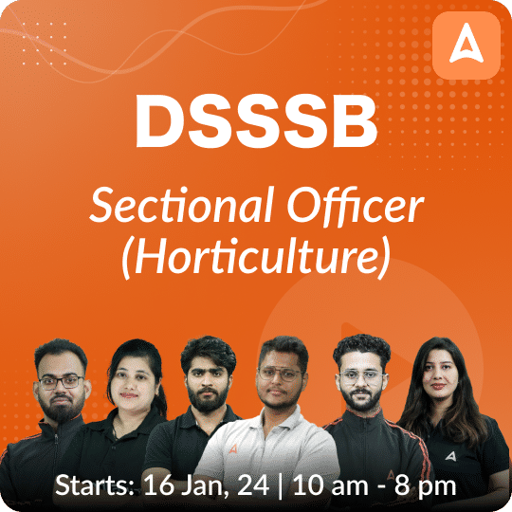](https://www.adda247.com/product-onlineliveclasses/46983/dsssb-so-horticulture-online-live-class-course?productId=46984)